Text:
Home Page Paragraph 1:
Starting a fire is often harder than it seems, especially when wood is damp or kindling will not stay lit. Liquid wood offers a simple, natural way to solve this problem. It is real wood that has been heated and broken down into a thick, pourable form that catches flame much more easily than solid logs. When a small amount is poured at the base of the fire, it lights quickly, burns steadily, and produces enough heat to help the larger pieces of wood ignite without repeated attempts. Because it is made entirely from wood, it burns cleanly, has no harsh chemical smell, and leaves very little residue. This makes it useful for fireplaces, campfires, wood stoves, and emergency situations. Liquid wood provides a dependable, easy‑to‑understand method for starting fires with far less effort, making the process more accessible for people of all ages and experience levels.

Home Page Paragraph 2:
While there may be concerns about this new product, this website is here to address some of these concerns, and help you to understand the benefits of this safe, eco-friendly product! Liquid Wood will be the last fire starter you ever need to buy! It is quick, safe, and leaves no harmful residue! This product is the perfect starter for campfires, grills, or whenever you need a quick, powerful fire to enjoy and use!

Carbon Footprint Page paragraph 1:
As stated, this product is not only super effective, but it is also environmentally friendly! Using all-natural wood, this product applies heat and pressure to turn wood into a liquid, without using any chemicals! This allows for the fires started, and used, by this product to emit clean, eco-friendly smoke and ash. As this product is intended to enhance you experience camping in nature, we want our product to not disrupt the beauty and cleanliness we are all trying to appreciate.

Carbon Footprint Paragraph 2:
To further add to its renewability, each container of Liquid Wood is refillable! Instead of needing to buy over and over the same bottle or jar, one can simply buy one big jar and refill the others for camping uses. Also, as Liquid wood becomes more popular, multiple locations will offer to refill the jars, removing all remaining excess containers! This will reduce the amount of extra garbage and recycling, further preserving the natural beauty that exists all around us. For those that wish to help more, reach out and contact us with new ideas or willingness to help! Our contact information is found on the bottom of each can, and we love to hear from users to better improve the quality of our product! Thank You!

Where to find Paragraphs:
Liquid wood is slowly making it debut across the american market, and may be found in stores near you! This product is available in three different forms. The first, and most popular version is the pour version. It comes in a small jar, allowing you to simply unscrew, and pour it where you need it! This is especially helpful for starting large bonfires or a grill. The second version is the spray style. This style is still popular but not quite as common, as it offers a more controlled spray of the liquid wood, but at a reduced quantity, reducing the wood starter possibly wasted in the process. This version is most popular for small campfires or for quick, small fires whenever needed.

The last variant, and newest version, is the liquid torch. This new version is a new way to have a natural light source when walking. Its long cylindrical shape makes it easy to hold, while keeping your hands away from the fire. The top end has a controlled surface to place the liquid wood inside, letting the torch burn for hours on end. This is most popular for those that want a truly electronic-free camping experience, and also for those wishing to be a part of Indiana Jones movies. Whichever version you pick, Liquid Wood is here to help ease your fire starting and maintaining needs, in whatever the circumstance!

Images:
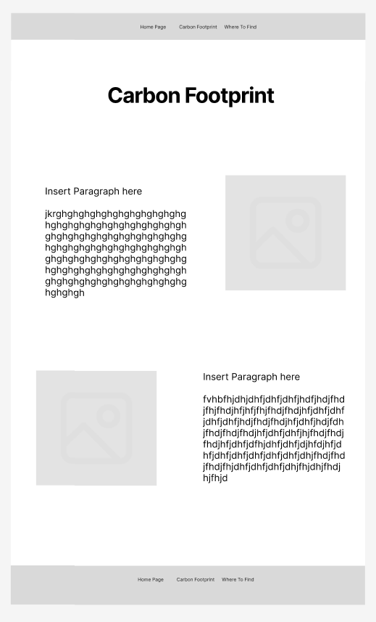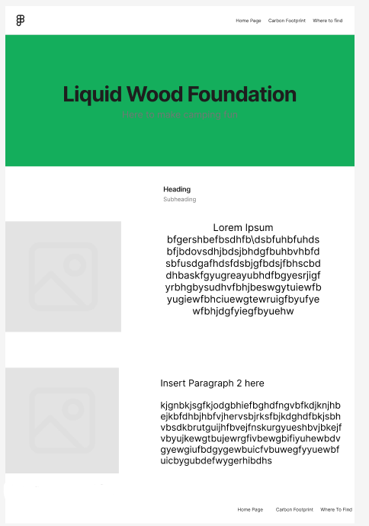
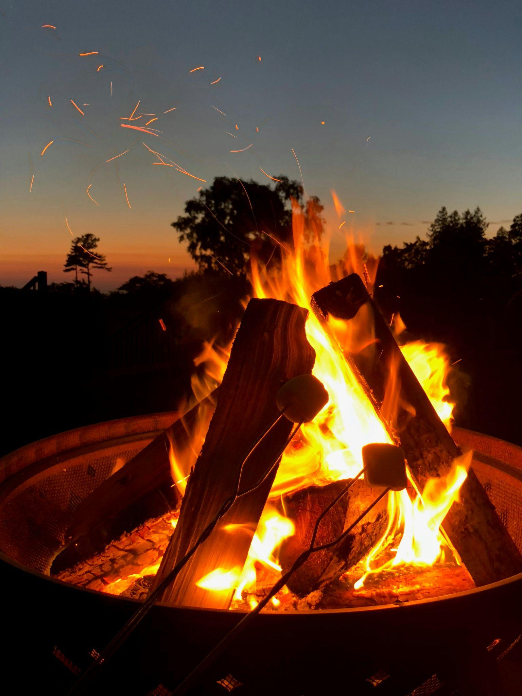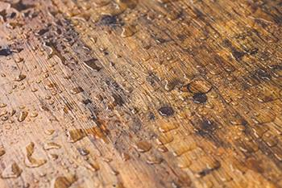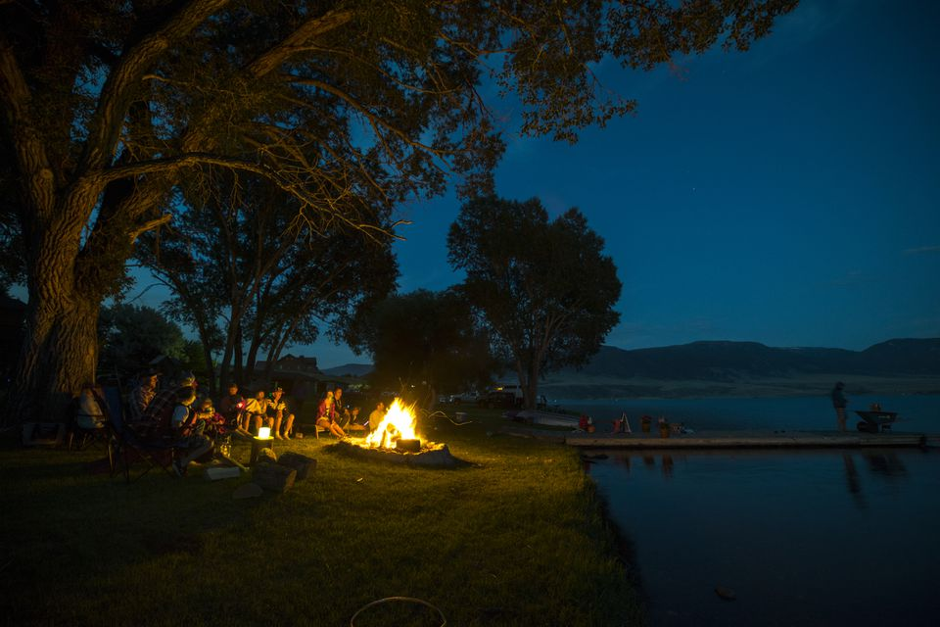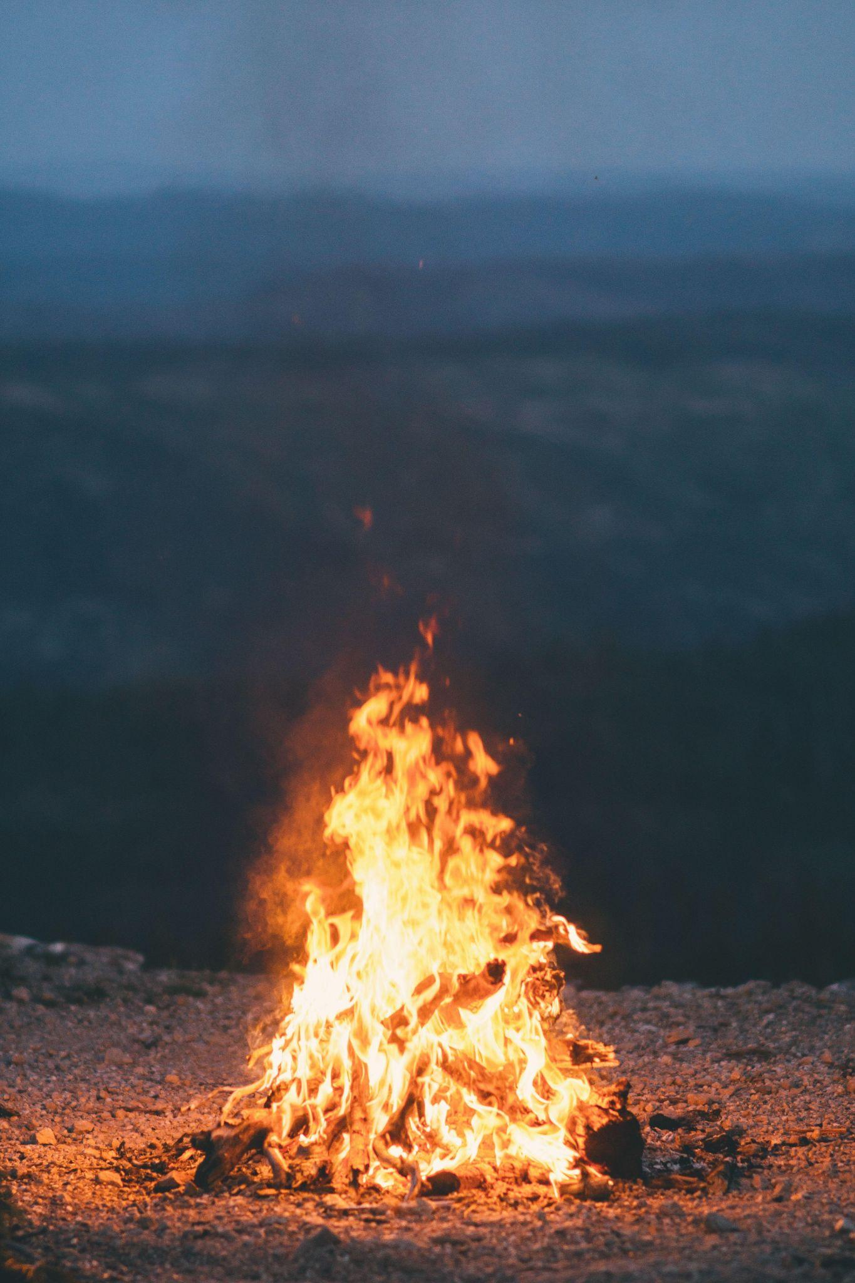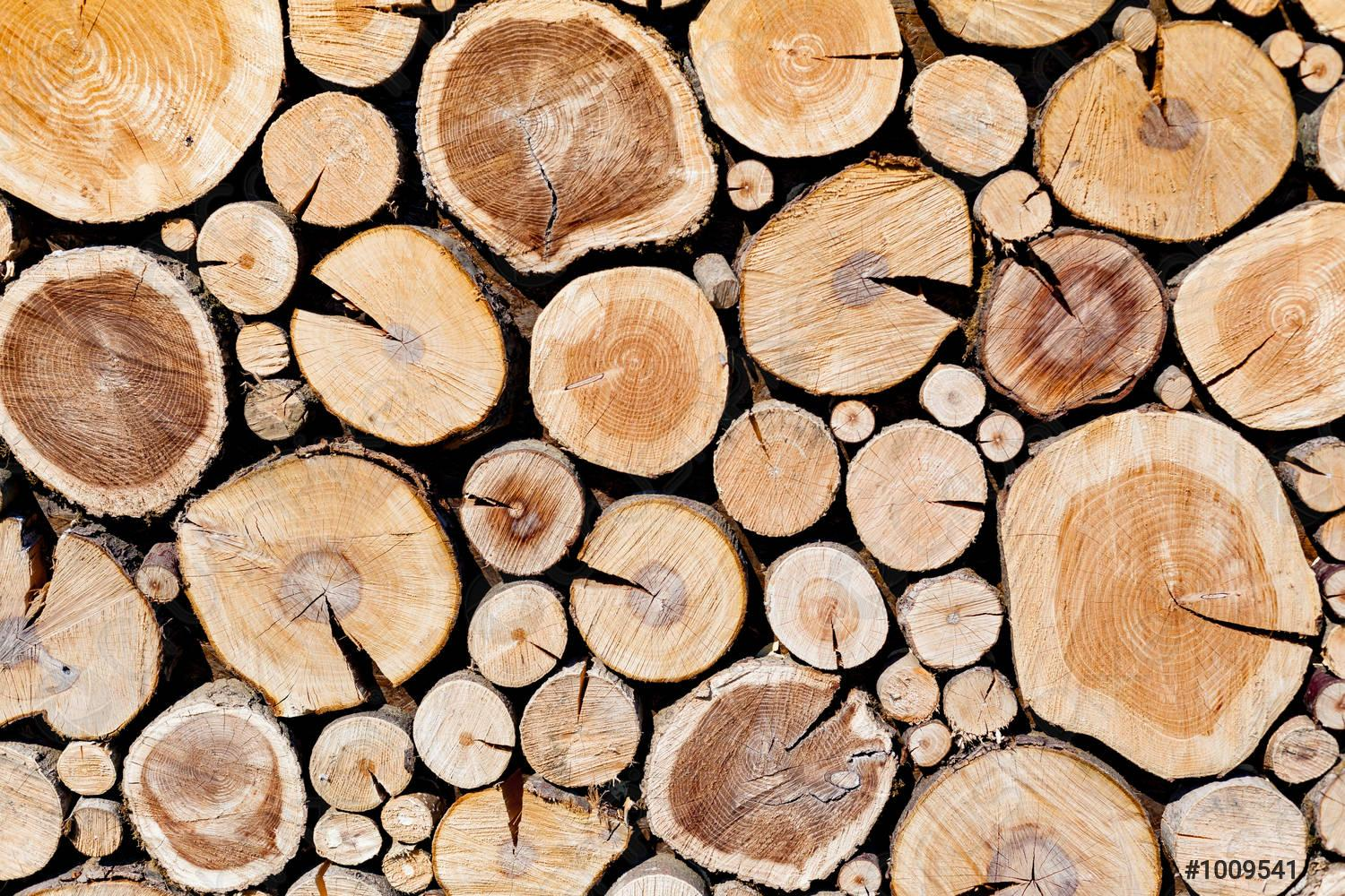

2. Purpose and Audience

The Purpose of this site is to provide information about the product of Liquid Wood, including possible sites to buy it. The purpose is to provide information on the product, to better market it to sell it in the real world. The target audience are those looking for information about quick tips on camping and fire starting.

3. Logo


4. Color Palette

#048A81
#06D6A0
#54C6EB
#8A89C0
#CDA2AB

Fonts:
Times New Roman, Times, Serif

